Room E Question 1
Advanced Breast Cancer
Stem: A 42-year-old female presented with a self-detected breast mass. Approximately 1 month ago, she discovered an ill-defined, large mass in her right breast while bathing. She denies any symptoms related to the breast including breast pain, nipple discharge, or changes to the overlying skin.
PMH: Denies
Family history: Unremarkable.
Meds: None
Social history: Nondrinker and nonsmoker.
Physical examination:
- Right breast mass measuring approximately 6 cm in size is in the upper central and upper inner quadrant.
- No overlying skin changes.
- No supra- or infraclavicular adenopathy
- Palpation of the right axilla is remarkable for adenopathy. The nodes are firm but mobile and nontender.
- Examination of the left breast and axilla is unremarkable.
- Vital signs are normal.

What is your differential diagnosis?
- Invasive ductal carcinoma.
- Invasive lobular carcinoma.
- Breast abscess
- Breast lymphoma
- Phyllodes Tumor.
- Metastasis from another primary.
- Fibroadenomas
How are you going to evaluate this patient?
- Thorough History: Assess for risk factors.
- Bilateral mammograms: The patient’s workup confirms the presence of a right breast mass measuring 6.5 cm.
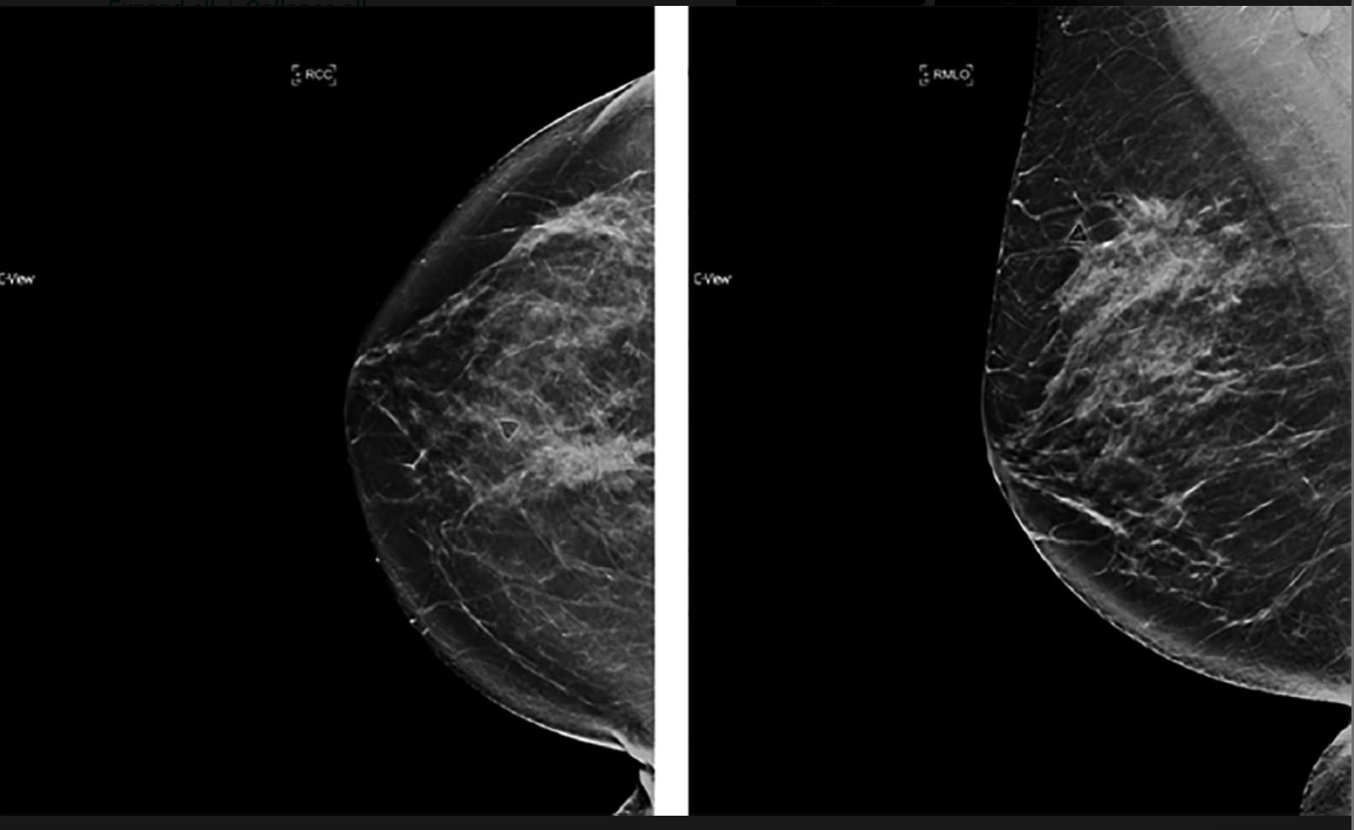
- Ultrasound of the mass and axilla : Ultrasound of the ipsilateral axilla demonstrates the presence of two large morphologically abnormal lymph nodes.

- Core biopsy: Invasive ductal carcinoma, grade III, ER negative, PR negative, and Her2 negative.

- FNA of the suspicious lymph nodes: Positive for metastatic disease.

- MRI can be considered
- Metastatic workup was negative for metastatic disease.
- No radiographic abnormalities were noted on the left breast or axilla.
What is your TNM stage for this patient?
- Clinical cT3N1, Stage IIIA, triple-negative breast cancer.
(The tumor is 6.5 cm in maximum diameter (T3). There is evidence of axillary lymph node involvement in the right axilla (N1), and there is no evidence of distant metastatic disease (M0). )
How would you manage this patient?
- Multidisciplinary discussion / Tumor boards.
- Genetic counseling ( premenopausal)
- In this case of Stage IIIA, locally advanced disease, there are two options:
  - Primary surgical management followed by adjuvant chemotherapy and adjuvant radiation.
    - Surgical management of the primary breast disease would consist of either a mastectomy or breast conservation therapy (i.e., lumpectomy, partial mastectomy, or wide local excision)
  - Or, neoadjuvant chemotherapy followed by surgery and adjuvant radiation. (Highly Recommended)

- In a premenopausal patient with triple negative Stage IIIA breast cancer, neoadjuvant chemotherapy would be recommended.
This Patient decides to pursue surgery first , what approach would you offer her ?
With a 6.5-cm tumor, the patient is not a candidate for breast conservation if surgical resection is performed first. Patient will need Mastectomy with axillary lymph nodes dissection (pathologically positive nodes prior to surgery.)
Describe Mastectomy steps?
- Elliptical incision to include the nipple–areolar complex and excess breast skin.
- Formation of superior and inferior skin flaps.
- Extend superiorly to the clavicle, inferiorly to the inframammary fold, laterally to the anterior border of the latissimus dorsi, and medially to the lateral edge of the sternum.
- Dissection of the breast off of the chest wall taking the pectoralis fascia.
- Hemostasis.
- Placement of a drain.
- Closure
Resident can consider, immediate reconstruction is planned, a skin-sparing or nipple-sparing approach may be used. Nipple-sparing is not commonly used for LABC. For a skin-sparing approach, a circular incision around the edge of the areola is used and the mastectomy performed through that incision.

Room E Question 2
Appendiceal Carcinoid
Stem: A previously healthy 68-year-old woman is seen in the ED with 18 hours of RLQ abdominal pain and CT findings showing acute appendicitis without perforation, abscess, or phlegmon. You proceeded with laparoscopic appendectomy, patient does well and goes home on POD 1.
Now she is in the clinic for post op, the pathology report had just been signed and released while she was waiting to be roomed. When you walk in to see her, she is obviously distressed and asking you “What is the plan, pathology is showing “tumor”” … She is crying.
Laparoscopic or Open Appendectomy (Describe

You pull the pathology report, and it shows …
- 6mm well circumscribed carcinoid tumor near tip of appendix with no lymphovascular invasion or evidence of perforation ?
  - Reassure, Nothing further

- Path Returns with 34mm well-circumscribed carcinoid tumor at mid appendix without evidence of perforation or lymphovascular invasion.
- PET-Dotatate or Octreotide scan post op, with tumor markers
- Right Colectomy (Describe)
-Open , lap or robotic
- Examine peritoneal surfaces, liver.
- Mobilize the right colon from lateral to medial or medial to lateral
- Enter lesser sac at hepatic flexure.
- separate omentum from transverse colon.
- Divide mesentery.
- Ligate ileocolic vascular pedicle. (Could be done before mobilizing the colon especially with medial to lateral mobilization) -
- Construct ileocolic anastomosis.
- Close mesenteric defect (surgeon preference).

4. Pathology returns with adenocarcinoma:

  - Stage the patient with CT C/A/P
  - CEA level
  - Colonoscopy if no recent one.
  - Right colectomy
- What if, there is a mucinous mass involving the base of the appendix. During mobilization and right colectomy there is spillage of mucin. What next?
Referral for evaluation for HIPEC.

Room E Question 3
Ischemic colitis / Post op leak
Stem: A 78-year-old man presents with sudden onset of left-sided abdominal pain. He complains of bloody diarrhea for the last few hours and anorexia without nausea or vomitting.
Physical Exam: Bl.pr 138/85. HR 112 bpm, Temp 100.5 F (38.0 C.) RR 14. He is slightly distended and tender in the left lower quadrant of his abdomen but does not have diffuse peritoneal signs.
Rectal examination no palpable masses but his stool is heme positive.
PMH: HTN, DM
- Labs: Hb 14.2 g/dL, WBC 15.5, lactic acid level of 0.8 mEq/L.
- CT scan : Shows mild descending and sigmoid colonic thickening
- Stool cultures negative.

What is your DDX?
- Ischemic colitis
- Malignancy
- Inflammatory bowel disease
- Infectious and other colitis (microscopic, eosinophilic, neutropenic, drug-induced, collagen vascular associated)
- Radiation enteritis or colitis
How would you manage this patient?
- Admit.
- Hydrate.
- Prophylactic Abx.
- Prep for a colonoscopy (Resident should say, they will do the colonoscopy and describe bowel prep / colonoscopy steps)
  - Colonoscopy shows erythematous mucosa with superficial ulcerations in the splenic flexure biopsies are consistent with ischemic colitis.
Now what?
Continue, expectant management with intravenous fluids, bowel rest, and broad-spectrum antibiotics. Restoration of adequate intravascular volume is paramount.

Patient initially starts to improve, but, then becomes acutely febrile and tachycardic. On examination, his abdomen is diffusely tender. How would you proceed.
Emergent Ex.lap.
You perform segmental resection for the ischemic portion of the colon, you notice brisk bleeding from the edges. The anesthesiologist assures you that that patient had been hemodynamically normal throughout… Would you perform anastomosis?
- Yes / Yes with proximal diversion
You decide to perform anastomosis, you think of making loop ileostomy but given your patient age you are worried it may lead to dehydration and worsening of his existing CKD.
This patient, initial postoperative course is unremarkable, but he developed confusion and agitation on the evening of postoperative day 4. His abdomen became more distended. You place and a nasogastric tube. He then developed low-grade fevers, On postoperative day 6, his clinical status acutely worsened, he becomes tachycardic with a heart rate of 130. He had marked abdominal distention and was tender across his lower abdomen with diffuse peritoneal signs.
Now what?
- Emergent Ex.lap / Resuscitation.
- Careful blunt dissection.
- Gentle exposure of the anastomosis if accessible.
- Assessment of the patient’s hemodynamic status.
- Resect and redo if stable / Repair/redo and proximal diversion if stable / anastomosis accessible.
- Resect and stoma if unstable.
You find a small defect at the anastomosis; you were able to repair it. Patient intraop was hemodynamically normal, you were satisfied with your repair and you decide again not to divert, your patient does well this time and gets discharged from the hospital. He thanks you for your care at his post op visit.

